Station to Station Sign Up Night
Appalachian Trail District Edition
Objective: to create a joining experience that is effective, efficient, and family-friendly.
- The station-to-station sign up night model is designed to increase flexibility for Packs and families.
  - Early arrivers do not have to wait, late arrivers do not miss anything
  - Families with time restraints can sign up in 15-20 minutes
  - Families with questions will have the opportunity to speak with leaders one-on-one
- At least 7 volunteers are needed to ensure an effective station-to-station sign up.
  - 1-2 people greeting and helping to direct families
  - 2-3 people at stations 1 & 2
  - Den leaders at Station 3
  - 1-2 people at Station 4
- In preparation for the sign up night, Packs can:
  - Arrive at least one hour early to set up and greet early arrivers
  - Supply a Pack calendar, contact list, and event fliers
  - Have a completed Pack budget to effectively explain costs and cost alternatives
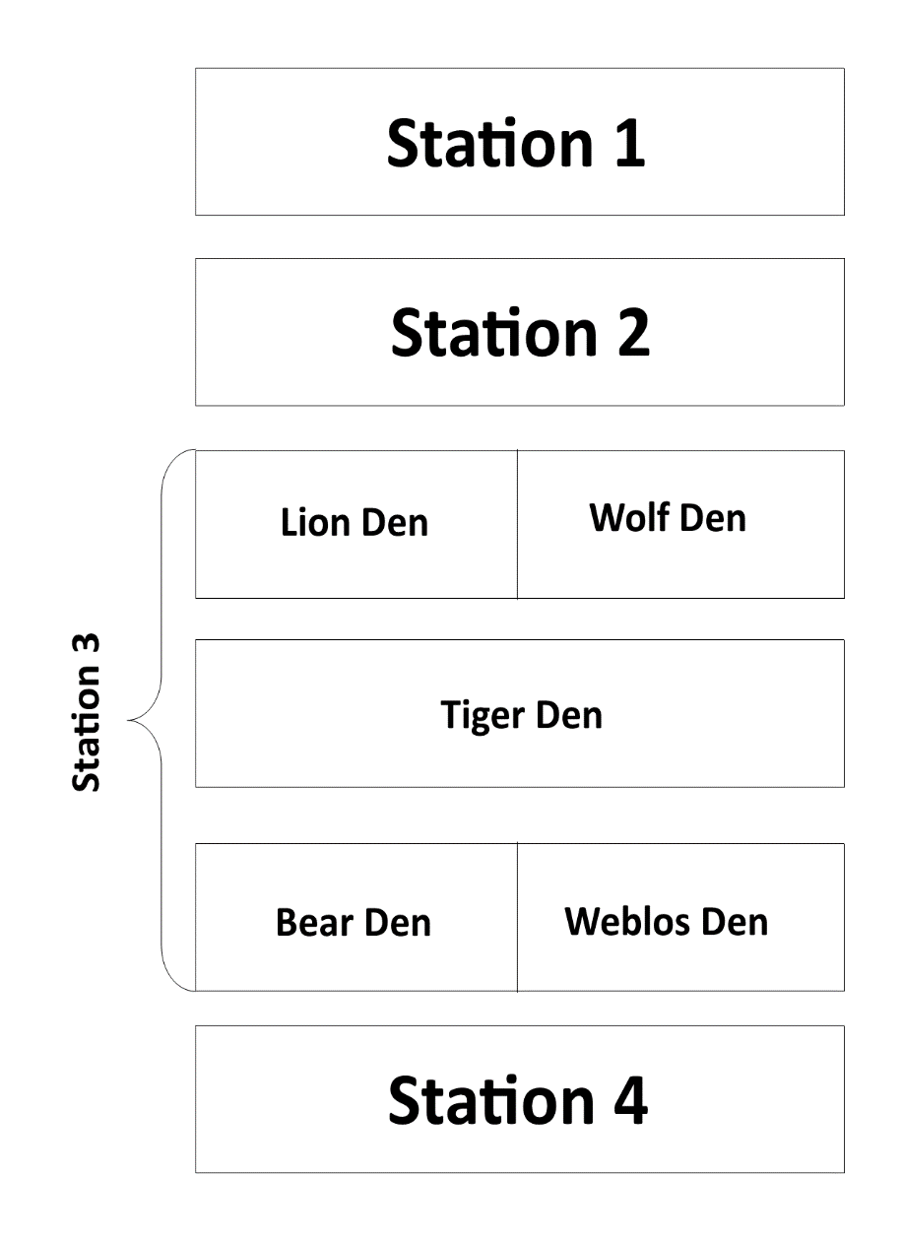
  - Have a fun activity planned soon after the sign up night
- Welcome
- What is Cub Scouting?
- Hand out applications to everyone
- Pack info: What we do
- Examples of activities/fundraising
- When/where we meet
- Den Leaders help new Scouts fill out applications
- Answer questions, talk with parents, give them a chance to get to know their new Den Leader
- Excellent opportunity to recruit parents; get them to fill out applications as well!
- Turn in applications
- Pay dues/registration
- Flyer for upcoming activity/meeting
Station 1: Welcome!
Goals
- Greet every family who attends and have them sign a Den Roster
- Give families an information packet and applications
- Very briefly explain the station-to-station process and direct them to Station 2
Supplies
- Applications
- Orientation packet (basic Cub Scouts info, leader contact info, Pack calendar, flyers)

- Station sign
- Den Rosters
- Pens
Station 2: What We Do, How We Do It
Goals
- Explain regular activity schedule and that attendance is encouraged but not mandatory
- Describe examples of past activities, show pictures, talk about upcoming events
- Explain BSA registration costs, Pack dues, uniform and costs, and Boy’s Life
- Explain cost alternatives (registration, camperships, books/uniforms) and fundraising activities
  - Create the expectation that a Scout helps to earn his own way by supporting Pack fundraising
Supplies
- Station sign
- Pictures and flyers of past activities—show the Pack having fun, Scouts and families together, doing fundraising activities.

- Registration assistance forms
- Popcorn Sales Guide
Station 3: Fill Out Applications
Goals
- Den Leaders direct families to complete applications and ensure they are filled out properly
- Welcome new families into Scouting, answer questions
- Discuss leadership opportunities for parents
Supplies
- Extra pens and applications

- Station sign
Station 4: Sign Up
Goals
- Collect payment
- Remind new Scouts about the next meeting, give them a separate flyer to remind them
Supplies
- Station sign
- Flyer for next meeting/activity
- New Scout incentive
  - Lego set, Pack-provided items (optional)

- Calculator
- Change
- Card Reader
- Receipt Book

