2017 Fall Camporee
Scottish Games
Leader’s Guide

Table of Contents
Registration 3
Pictures and Social Media 3
Food and Housing / Tents. 3
Location 4
Check 5
Bathrooms / Facilities Highlights 5
Concerns / Commitments to the City of Canton 5
Cooking / Fires 5
Water 5
Park is Open to Visitors 5
Things to Avoid. 5
Events 6
Schedule 6
Dressing in Theme 7
Scoring 8
Scottish Games 8
Spirit Awards 8
Theme based bonus points 8
Leadership based points 8
Leading / Running a Game 8
Campfire Program based points 8

Registration
Registration is officially open thru DoubleKnot.

http://www.atlantabsa.org/event/at-fall-camporee/2185786

Pre-Registration closes the day before the event.

Pictures and Social Media
We are encouraging Social Media. Post “Scout Appropriate” Pictures on Facebook, Instagram, and Twitter with the hashtag #atcamporee2017. Make a splash in the community.

Food and Housing / Tents.
You are responsible for all food and tents.

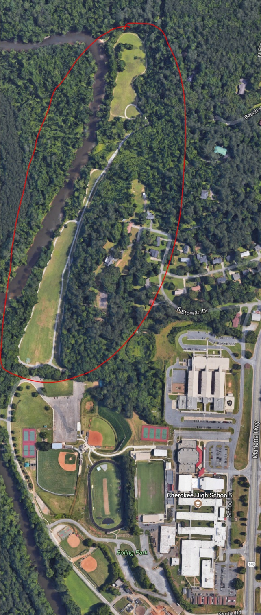
Location

Boling Park
1200 Marietta Hwy
Canton, GA 30114

Check-In

Check-in starts at 5pm in the rear of the park just inside the walking path.
Park adjacent to the Baseball fields and the Tennis Courts.

Bathrooms / Facilities Highlights
There will be porta-potties and handwashing stations at the event. As this is a public park, please encourage scouts to use only them. It is not a time to be creative.

Concerns / Commitments to the City of Canton

Cooking / Fires
Cooking should be limited to Coleman stoves off the ground. Please be very careful.
There is Dutch oven cooking is allowed at the pavilion. Ensure that there is no trace of your cooking. No ashes or burnt grass in the fence surrounding the pavilion.
The BSA is insuring the City against any loss of property. I am sure this will not be an issue.

Water
There is very limited water on property. Plan accordingly. Bring all water you need for the weekend. We are working to provide more, but at this moment plan providing all that your troop needs.
There will be a water horse for water, but it is essentially a single source for 200 participants remember to be patient and gracious.

Park is Open to Visitors
We need to vigilant about providing some over sight within your given camp site during the event. The park is still open and we cannot shut it down. I hope to see the newspaper there taking pictures.
Troop Trailers can be parked at their sight. It is recommended that the back of the trailer be to the inside of the track.

Things to Avoid.
There are gas powered lights on the field for football games. They need to be left alone.

Events

Archery : Jeff Mathis and T316
Axe Throwing: T4900
Cabor Toss: T8880
Fells Relay Race (with Scout Skills): T1755
Tug a War: T3752
Hammer Throw: T469
Stone Put: T637

Schedule
Friday
 | 5:00 pm | Check-In
 | 9:00 pm | SPL Meeting / Cracker-barrel
 | 11:00 pm | Taps
Saturday
 | 6:30 am | Reveille
 | 7:00 am – 8:00 am | Breakfast
 | 8:30 am | Flag Ceremony (Parade Field)
 | 9:00 am – 12:00 pm | Scottish Games
 | 12:00 pm – 1:00 pm | Lunch
 | 1:00 pm – 3:00 pm | Wrap up Scottish Games
 | 4:30 pm – 7:00 pm | Scottish Feasts (at campsites)
 | 8:00 pm | Campfire and Awards
 | 11:00 pm | Taps
Sunday | 9:00 am | Interfaith Religious Service
 | 10:00 am – 11:00 am | Pack, Checkout, and Depart

Dressing in Theme

There are many avenues in selecting a kilt. A group that we have worked with in the past is StillwaterKilts.com. They have lots of inventory and a quick turn around on orders.
http://store.stillwaterkilts.com/scoutkilts.html
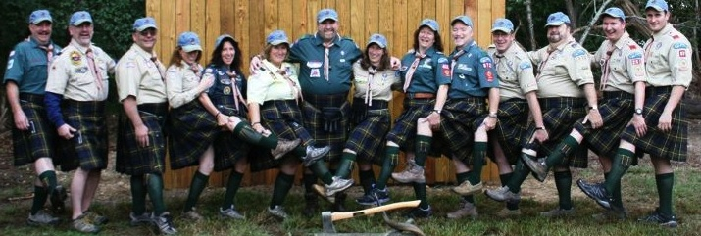

Scoring

Scottish Games
Archery: Highest total points for 5 arrows
Axe Throwing: Highest total points for 3 axe throws
Cabor Toss: one practice and one for points. Longest distance from the farthest point.
Fells Race (with Scout Skills): Scout skill relay race. Shortest time.
Tug a War: Troop against troop. Brackets will be posted by at PLC on Friday night. SPL will need to sign up at the PLC. Single elimination.
Hammer Throw: One practice and one for points. Longest distance from the farthest point.
Stone Put: One practice and one for points. Longest distance from the farthest point.
** Stone Put, Hammer Throw, and Cabor Toss will have lighter weights for our youngest scouts.

Spirit Awards

Theme based bonus points
Troops that come dressed in theme, cook theme appropriate meals, and camp in theme will have extra bonus points reflected in the scoring.

Leadership based points
Troops that provide a leader to help with scoring, logistics, parking, running an event, will have extra bonus points reflected in the scoring.

Leading / Running a Game
Troop that lead a game will get extra points..

Campfire Program based points
Troops that provide skits and songs in the campfire program will have extra bonus points reflected in the scoring.

